C Programming

* **History of C Language :-**
* It is a Procedural Language.
* C is a object base Programming Language created by Dennis Ritchie of AT & T Bell Laboratory
* USA is 1972.
* **Advantage of C Language :-**
* C is a Small Language with very few words hardly 32.
* C is the Standard Development Language For PC many Operating System add package are written using the C Language.
* **Requirement for C Language :-**
* Operating System MS-Dos
* Unix
* Linux
* Quick C
* Microsoft ‘C’
* Turbo C 3.0, etc…
* C programs have to be written first compile to check the error compile on they have to be link to create.
* Execution(.ex) File.
* **C Program Structure :-**
* #include<stdio.h> :- Standard Input Output File.
  + printf() :- Print any String.
  + scanf() :- Value Enter Input.
* #include<conio.h> :- Console Input Output File.
  + clrscr() :- Clear Screen.
  + getch() :- Show Output.
* Void main() :- Do not return any value.

} Beginning of Program.

Statement;

}

* **Void Main()**
* Every C Program Start with Functionvoid main().
* All Statement in C ends with semicolon (;).
* {} Indicates the begin & end of a block Statement & Function.
* **Expense Sequence used in Printf().**
* \n :- New Line
* \t :- Horizontal Tab
* \a :- Alert
* \\ :- Back Slash
* \b :- Back Space
* \r :- Carriage Return
* \” :- Double Quote
* \f :- Form feed
* **Variable Declaration**
* Program use variables to store data.
* All Variable/Contents must have a name.
* **Rules for Variables/Constant Name**
* Maximum Length is 31 Characters.
* Variables contain Alphabets, Digits & Underscore (_).
* They are Case Sensitive
* Must Start with an Alphabet or an Underscore.
* They must be Unique.
* **Data Type :-**

|  |  |  |
| --- | --- | --- |
| **Type** | **Size in Byte** | **Range** |
| Char | 1 | -128 to +127 |
| Int | 2 | -32768 to +32767 |
| Float | 4 | +3.4e-38 to 3.4e+38 |
| double | 8 | 1.7 e-308 to 1.7 e+308 |

* **Format Character**
* %c = Single Character
* %d = Integer
* %f = Floating Point
* %s = String
* %o = Octal Integer
* %x = Hexadecimal Integer
* **The #define Directive**

A # define is a pre-processor compiler Directive and not a statement. There for #define lines should not end with a semicolon symbolic constants are generally written is uppercase so that they are easily distinguished from lowercase variables name #define instructions are usually placed at the beginning before the main() function. Symbolic constants are not declared in declaration section. Prosecesseor directives are discussed in ch 14.

The #include Directive:

As mentioned earlier, C programs are divided into modules or funvtion. Some functions are written by users, like us, and many others are stord in the c library. Library functions are grouped category.wise and stord in different file known as header files. If we want to access the functions stored in the liberary, it is necessary to tell the compiler about the flies to be accessed.

#include<filename> eg.. # include<stdio.h>

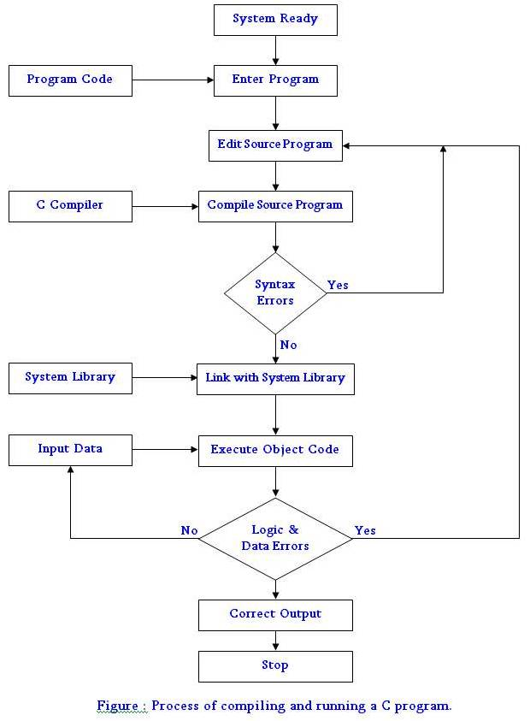Filename is the name of the library file that contains the required function definition. Pre-processor directives are placed at the beginning of a program.

C character set:

Uppercase A to Z

Lowercase a to z

All decimal digits 0 to 9

**Special Characters.**

, Comma

. Period

; Semicolon

: Colon

? Question mark

‘ Apostrophe

“ Double quotation mark

! Exclamation Mark

| Vertical bar

/ Slash

\ Back Slash

~ Tilde

_ Underscore

$ Dollar sign

% Percent sign

& Ampersand

^ Caret

* Asterisk

- Minus sign

+ Plus sign

< Opening angle bracket

> Closing angle bracket

( Left Parenthesis

) Right Parenthesis

[ Left Bracket

] Right Bracket

{ Left brace

} Right brace

# Number Sign

**White Spaces**

Blank Space

Horizontal Space

Carriage Retune

New Line

Form Feed

**Logical Operators**

== Equal to

&& And

|| Or

!= Is not qual to

\0 Null char

**ANSI C trigraph Sequences:**

Trigraph Sequence

??=

??(

??)

??<

??>

??!

??/

??^

??_

# Num sign

[ Left bracket

] Right bracket

{ Left bracket

} Right bracket

| Vertical bar

\ Back slash

^ Caret

~ Tilde

ANSI C Keywords:

auto

break

case

char

const

continue

default

do

double

else

enam

extern

float

for

goto

if

int

long

register

return

shout

signed

sizeof

static

steuct

switch

typedef

union

unsigned

void

volatile

while

Structure of C:

1. Hello World!.. print

#include<stdio.h>

void main()

{

printf(“Hello world!”);

}

1. My name

#include<stdio.h>

void main()

{

printf(“Femina”);

}

OLP: Femina

1. BioData

#include<stdio.h>

void main()

{

    printf("\n Fist Name: Dhaval");

    printf("\n Middle Name: Pankajbhai");

    printf("\n Last Name: Leelawala");

    printf("\n Address: B-123, Abc app, surat");

}

1. p4_var_int

#include<stdio.h>

void main()

{

    int a;

    a=10;

    printf("a is: %d",a);

}

1. p5_float_var

#include<stdio.h>

void main()

{

    float a;

    a=10.25;

    printf("a is: %f",a);

}

1. p6_char_var

#include<stdio.h>

void main()

{

    char a='c';

    printf("a is: %c",a);

}

1. p7_sum

#include<stdio.h>

void main()

{

    int a,b,sum;

    a=10;

    b=20;

    sum=a+b;

    printf("\n a is: %d",a);

    printf("\n b is: %d",b);

    printf("\n sum is: %d",sum);

}

1. p8_area_of_circul

#include<stdio.h>

void main()

{

    int r;

    float area;

    r=5;

    area=3.14*r*r;

    printf("\n r is: %d",r);

    printf("\n area is: %.2f",area);

}

1. p9_area_of_rectengular

#include<stdio.h>

void main()

{

    int w,l;

    float area;

    w=15;

    l=7;

    area=w*l;

    printf("\n w is: %d",w);

    printf("\n l is: %d",l);

    printf("\n area is: %.2f",area);

}

1. p10_simple_interest

#include<stdio.h>

void main()

{

    //P:-Principal amount

    //N:-Number of year

    //R:-Rate of interest

    int P=10000,N=4,R=6;

    float Interest;

    Interest=P*N*R/100;

    printf("\n P is: %d",P);

    printf("\n N is: %d",N);

    printf("\n R is: %d",R);

    printf("\n Interest is: %.2f",Interest);

}